Increased Prevalence of Anal Cancer in IBD patients, Especially in Crohn’s Patients with Perianal Disease and UC patients with Anal-Area High-Risk HPV-Positive DNA
Table of contents

Increased Prevalence of Anal Cancer in IBD patients, Especially in Crohn’s Patients with Perianal Disease and UC patients with Anal-Area High-Risk HPV-Positive DNA
Prior studies have established an increased rate of anal cancer in patients with IBD. Per Albuquerque et al., the incidence of anal cancer per 100k person-years is as follows: 2 in the general population. 7.7 in Crohn’s, and 10.2 in Ulcerative Colitis. Notably, if a Crohn’s patient had prior perianal disease, it was 19.6 per 100k person-years, or 10 times the incidence. (Albuquerque et al. 2023)
When looking at IBD patients in general within the Epic Cosmos dataset, we also found higher incidences of anal cancer in the IBD population. When separating by Crohn’s vs Ulcerative Colitis, there is a 5x increased prevalence in Crohn’s patients, and a 6.4x increased prevalence in Ulcerative Colitis patients.
Patient Type | Anal Cancer or Dysplasia (total) | Anal Cancer or Dysplasia 5 years after Perianal Disease diagnosis | Positive High-Risk HPV diagnosis in anal area (total) | Anal cancer or dysplasia 5 years after High-Risk HPV diagnosis
Non-IBD (n=305,065,760) | 128,173 (0.0420%)* | 10,195 (0.0033%)* | 22,867 (0.0075%)* | 9,404 (0.0031%)*
Crohn’s Disease (n=1,206,873) | 2,535 (0.2100%)* | 575 (0.0476%)* | 197 (0.0163%)* | 97 (0.0080%)*
Ulcerative Colitis (n=1,191,972) | 3,227 (0.2707%)* | 488 (0.0409%)* | 319 (0.0268%)* | 149 (0.0125%)*
*=Row-level Pearson chi-square test p < 0.001.

Perianal Disease in Crohn’s
This relative increase in UC is true in most sectors we analysed, the one exception being prior perianal disease - in that case, Crohn’s patients had the higher prevalence. This is consistent with Albuquerque et al.’s finding of high prevalence of anal cancer with Crohn’s patients with perianal disease.
Of note, It is unclear what role surveillance of the IBD population may have affected discovery. For example, patients with perianal disease may be more likely to be evaluated.
However, if there is a high ratio of perianal disease patients that develop anal cancer, surveillance alone may not explain the higher rates. In a previous surgical study of a group of 33 IBD patients by Slessler et al. found that 85% of Crohn’s patients with anal cancer previously had perianal disease. However, this was specifically a group of anal SCC patients, so it is difficult to assess how this group relates to the larger body of Crohn’s patients with perianal disease. (Slesser et al. 2013)

Severity and Aggression of Anal Cancers in Crohn’s patients
Slessler et al. noted earlier age of presentation and poorer outcomes with the select group of anal SCC patients in their retrospective analysis. I think this is something we should dig deeper into - how do we measure severity - is a combination of staging of the malignancy and age enough of a metric?

Perianal Disease and Anal Cancer
About 22% of Crohn’s patients with Anal Cancer had Perianal disease in the 5 years prior to diagnosis (559/2535). For UC, about 15% had prior perianal disease (474/3227). Chi-Square of 52.3, p<0.001. In the general population, there was a minimal percentage of patients that had perianal disease, however we hypothesize that such rate is not comparable as screening for such a condition is not routine and likely skews the percentage.
Prior perianal disease No prior perianal disease
Crohn disease 559 1976
Ulcerative colitis 474 2753
Pearson's Chi-squared test
data: perianal_anal_cancer_counts
X-squared = 52.307, df = 1, p-value = 4.748e-13
Pearson chi-square testing showed that prior perianal disease was significantly more common among Crohn’s patients with anal cancer than UC patients with anal cancer, X²(1) = 52.3, p < 0.001.

Proposed Mechanisms, Discussion, Areas to Further Study

Anal Sparing in Ulcerative Colitis
While rectal involvement is Ulcerative Colitis is nearly universal, the anal canal is generally spared. This would seem to contradict the data that shows a higher rate of anal cancer in UC patients. High-Risk HPV rates are also increased at this location, which may factor into the higher rates of anal cancer.

Azathioprine Use Does Not Seem to Correlate
Azathioprine is known to have some correlation to HPV and Cervical cancer, so we analysed if incidence of anal cancer in HRHPV+ patients may be increased in patients using Azathioprine. There was a higher use rate of Azathioprine for patients who had Crohn’s (7.48%) than Ulcerative Colitis (5.21%). However, when looking at patients with both IBD and anal HRHPV+ DHA, less than 10% of Anal HRHPV+ Crohn’s patients were on Azathioprine, and less than 5% of Anal HRHPV+ UC patients were on Azathioprine.
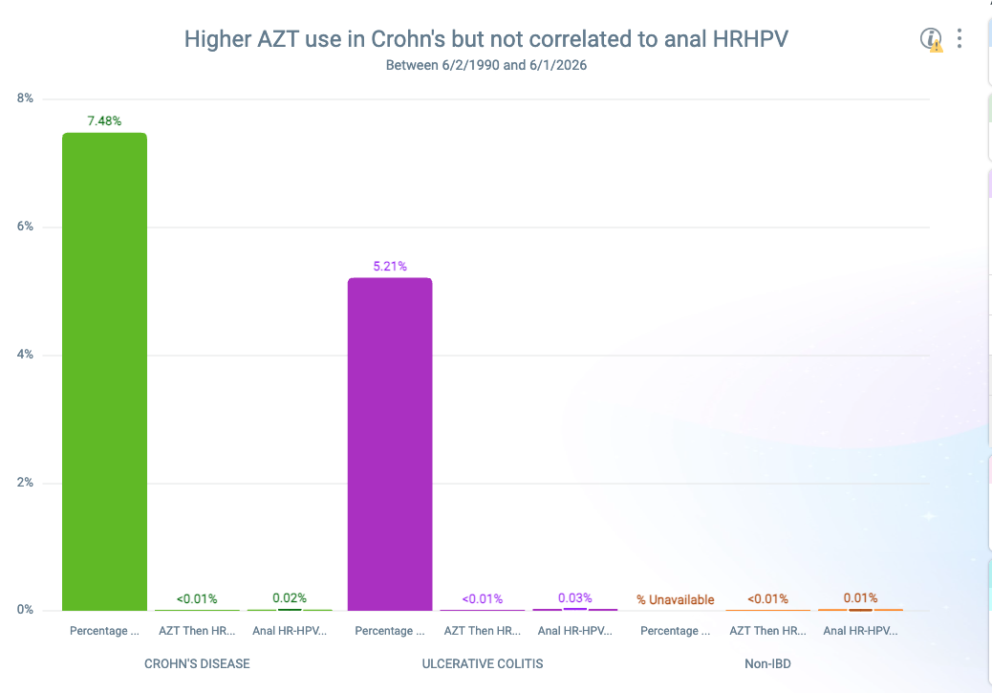

Future Proposals
Clinics that specialize in IBD may benefit from regular HPV screenings and vaccination. UC patients may benefit from regular anal cancer screenings, especially those positive for HPV. Crohn’s patients with perianal disease may significantly benefit from regular anal cancer screenings.
Given the small percentage of patients with the affected conditions, it may be more feasible to do large prospective studies on Crohn’s patients with perianal cancer, doing regular screenings in a multi-center study to analyse rates of perianal dysplasia. It would also allow study of severity, analysing age of presentation and rate of progression, to see if these patients suffer from more aggressive presentations.
Also a possibility is more regular screenings of IBD patients for HPV. While this data specifically looks at HR-HPV in anal tissue, screenings for HPV may be of benefit, and HPV+ patients may benefit from regular screenings of HR-HPV+ DNA in the anal region. The populations sizes are small (Anal-area High-Risk HPV positive DNA is roughly 600 out of 2.4 million IBD patients, roughly 6,000 out of 2.4 million IBD patients with anal cancer),
With the higher rates of Anal-area High-Risk HPV positive DNA in IBD patients, regular screening for these patients may have an outsized effect on rates of anal cancer.
Albuquerque, Andreia, Carmelina Cappello, Oliver Stirrup, and Christian P Selinger. 2023. “Anal High-risk Human Papillomavirus Infection, Squamous Intraepithelial Lesions, and Anal Cancer in Patients with Inflammatory Bowel Disease: A Systematic Review and Meta-analysis.” Journal of Crohn’s and Colitis 17 (8): 1228–34. https://doi.org/10.1093/ecco-jcc/jjad045.
Slesser, A. A. P., A. Bhangu, M. Bower, R. Goldin, and P. P. Tekkis. 2013. “A Systematic Review of Anal Squamous Cell Carcinoma in Inflammatory Bowel Disease.” Surgical Oncology 22 (4): 230–37. https://doi.org/10.1016/j.suronc.2013.08.002.

